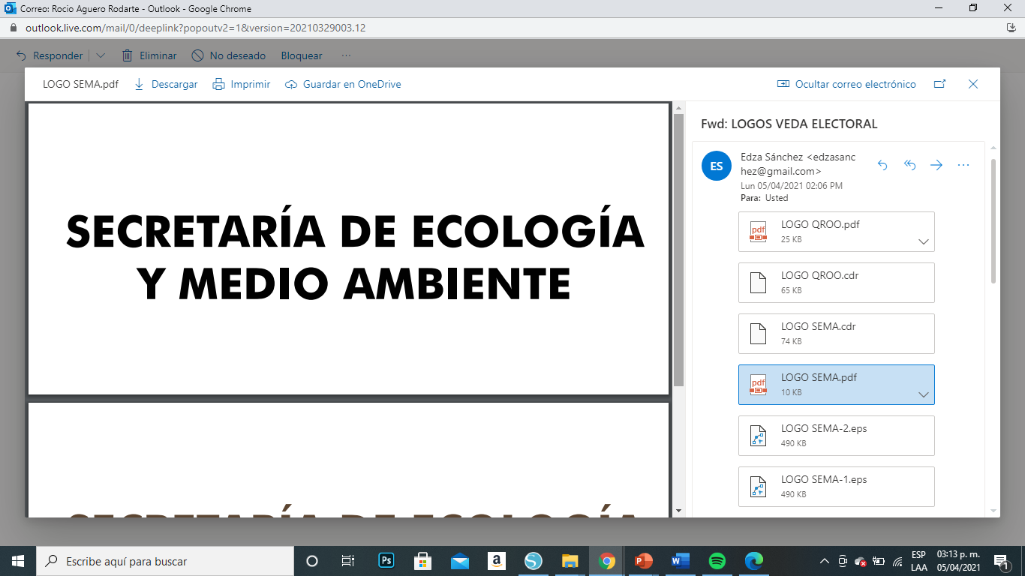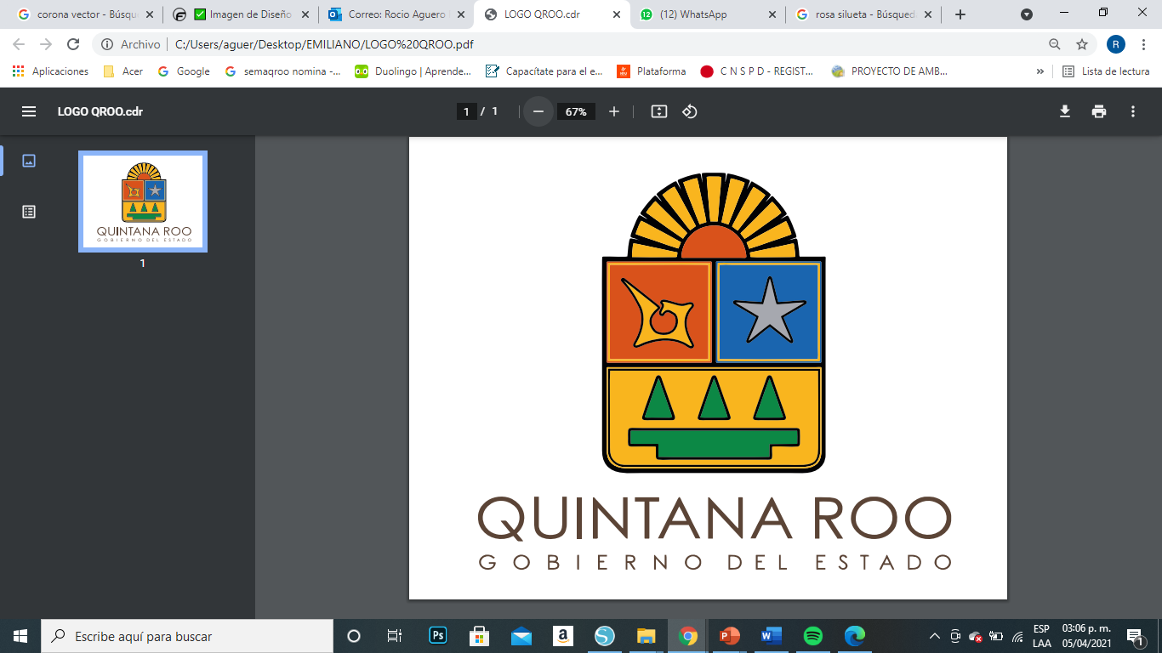

**SOPA DE LETRAS**

Encuentra el nombre de las cuatro tortugas que llegan a las playas de Quintana Roo

|  |  |  |  |  |  |  |  |  |  |  |  |  |  |
| --- | --- | --- | --- | --- | --- | --- | --- | --- | --- | --- | --- | --- | --- |
| S | D | G | X | D | H | J | L | F | E | W | X | V | V |
| F | D | L | A | U | D | V | V | X | X | S | D | X | V |
| U | D | S | C | S | S | X | A | L | U | D | O | U | L |
| S | S | O | A | D | F | L | C | A | R | E | R | S | W |
| S | D | D | C | G | F | E | A | A | T | U | L | V | B |
| Q | Q | Q | B | L | A | A | R | T | G | F | O | F | Q |
| H | F | H | C | A | U | Y | E | T | H | U | J | H | T |
| Q | C | C | V | D | G | G | Y | V | D | J | A | S | L |
| S | D | C | D | D | F | E | J | G | S | U | F | M | Ñ |
| S | C | A | P | A | R | A | Z | O | N | D | E | Q | A |
| Z | X | X | Z | V | H | J | Z | K | Y | M | U | O | O |
| D | C | V | E | R | D | E | A | F | F | D | M | S | D |
| Z | D | G | D | U | D | U | S | D | V | U | K | C | O |
| X | C | V | M | Z | J | C | Z | V | B | C | V | D | D |

